Steven Kim  
Mr. Mason  
Adv Cisco CCNP P1,2  
9/23/13

**Lab 2 – Dual Stack Routing**

**Purpose**

The purpose of this lab was to familiarize ourselves with running IPv4 and IPv6 simultaneously using OSPF, OSPF v3, RIP, and RIPng as routing protocols. Throughout this lab I was required to set up 8 different networks. In order to successfully ping between them, I had to learn how to redistribute different routing protocols in each IPv4 and IPv6.

**Background Information on Lab Concepts**

OSPF, or Open Short Path First, is a link-state routing protocol that makes use of a unique domain (single autonomous system, or AS) by gathering information from every router and creating a topology. It uses path cost as its metric. OSPF v3 is a simply variation of OSPF that allows routing between IPv6 addresses.  
 RIP, or Routing Information Protocol, is a distance-vector routing protocol that allows information to be transferred across the network without routing loops. It also uses hop count as its metric, and the maximum number of hops that a packet may travel is 15. Like OSPF v3, RIPng is a variation of RIP that allows routing between IPv6 addresses.  
 To run all 4 routing protocols simultaneously, I used an IPv6 implementation called Dual Stack. Dual Stack is a concurrent run of IPv4 and IPv6 addresses with their respective routing protocols; it does not need the encapsulation of IPv6 to IPv4, which is also known as tunneling. Dual Stack, although sometimes difficult to implement, is more efficient than tunneling since IPv4 and IPv6 can run together without interference.

**Lab Summary**

In this lab, I used a Catalyst 6500 Switch in the middle with 6 different Routers. I configured the top 2 routers with RIP and RIPng and the bottom 4 Routers and Switch with OSPF and OSPF v3. The Switch in the middle acted as a branch for redistribution.  
 To do this, I had to enable IPv6 unicast-routing on each Router/Switch, set up respective IPv4 and IPv6 addresses, and enable the protocols. Setting up IPv6 was relatively simple; I did not need any additional commands besides **ipv6 unicast-routing** (which allows IPv6 to be enabled on a Router/Switch) and   
 After my initial setup was completed, I set up the routing protocols, OSPF and OSPF v3 on the bottom Routers and Switch, and RIP and RIPng on the top Routers and Switch.   
 To ensure that communication between networks, including redistribution, was functioning properly for both IPv4 and IPv6, I used the commands **show ipv6 route** and **show ip route.** Initially, some routers did not have any routes marked as either “R” or “O,” so I quickly checked the absent network portions and troubleshot using the command **show run** and implemented missing commands.  
 However, as soon as I notice that networks with “O E2” marked next to them were not present, began to troubleshoot for the redistribution commands that were entered. After a considerable amount of time, I realized that the command that needed to be issued was **redistribute ospf 1 metric** command.  
 Finally, to ensure everything worked properly, I used the **show ip route, show ipv6 route, tracert, and ping** command once again to verify that communication was properly functioning. All the hosts could ping which meant that Dual Stack Routing was enabled successfully.

**Lab Commands**

To initially enable IPv6, the command *Router (config) # ipv6 unicast-routing* must be issued on every Router and Switch. Since we are enabling Dual Stack Routing, both IPv4 and IPv6 addresses must be entered on every interface. I simply used the command *Router (config-if) # ipv6 address [network::number/64]* to issue an IPv6 address. The Switch configuration commands are the same as those of Routers. Before doing the next steps, set up RIP and OSPF for IPv4 (as well as the router ids).  
 After setting up the IPs, issue the command *Router (config-if) # ipv6 router rip [name]* and on the top two Routers and Switch to enable RIPng. To run dual stack, the RIP for IPv4 must also be configured. Note that RIPng is configured on each interface while RIP is configured on each router (global config mode).  
 Now we must set up OSPF v3. To do this, issue the command *Router (config) # ipv6 router ospf 1* on the bottom Routers and Switch. This command does not need additional network statements for OSPF v3 to function; the command automatically establishes the network statements. After that, set the router id by issuing the command *Router (config) # router-id [ip address]*.  
 Finally, we must redistribute routes for RIP and RIPng, and OSPF and RIP to communicate with each other. For IPv4 redistribution, simply type in the commands *Switch (config)# router ospf 1* then *Switch (config-rtr) #* *redistribute rip subnets.* Then, issue the command *Switch (config) # router rip* then *Switch (config-rtr) # redistribute ospf 1 metric 10.* These two commands will enable redistribution between RIP and OSPF.  
 For IPv6 (RIPng and OSPF v3), after typing the command Switch (config)# ipv6 router ospf 1, which directs us to *Switch (config-rtr) #*, issue the command *Switch (config-rtr) # redistribute rip cisco metric 10.* Do the same for RIP: after typing *Switch (config) # ipv6 router rip cisco*, issue the command *Switch (config) # redistribute ospf 1 metric 10.* These two commands will allow redistribution between RIPng and OSPF v3.

**Network Diagram with IP’s**

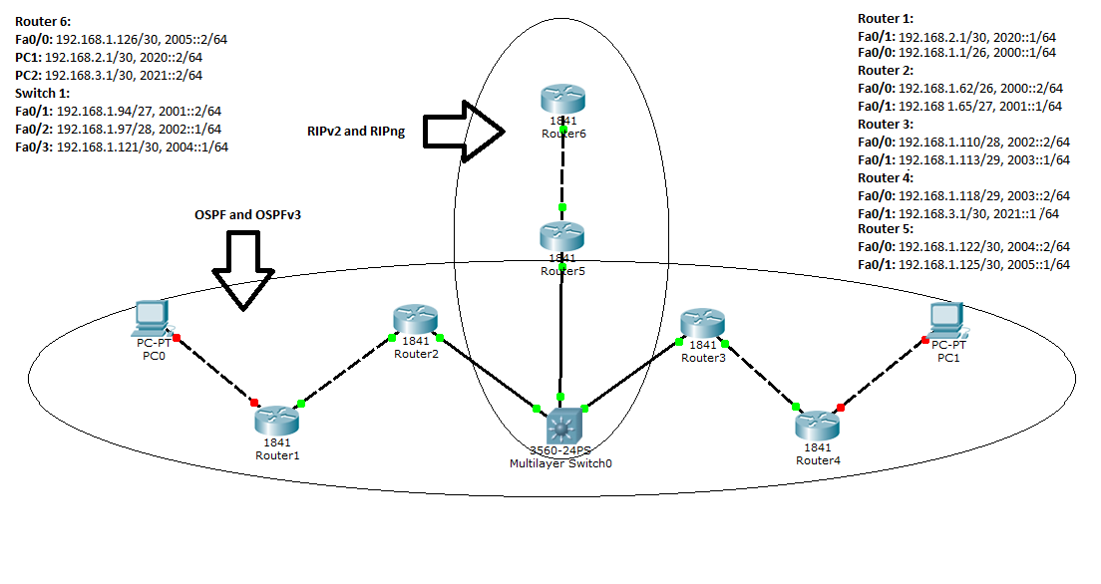

Note: On the Switch, the interfaces were fa4/1, fa4/2, and fa4/3. The area id for OSPF and OSPF v3 is 1.

**Configurations**

**Ping and Tracert between both PCs and Router 6**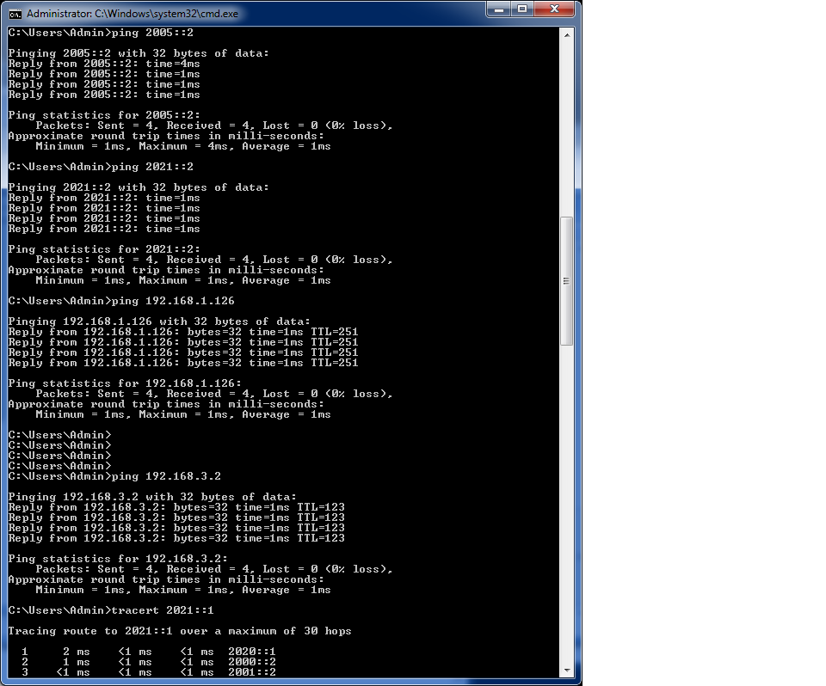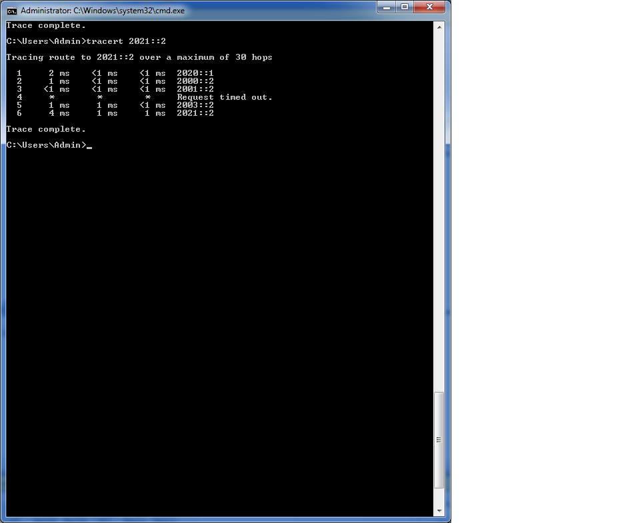

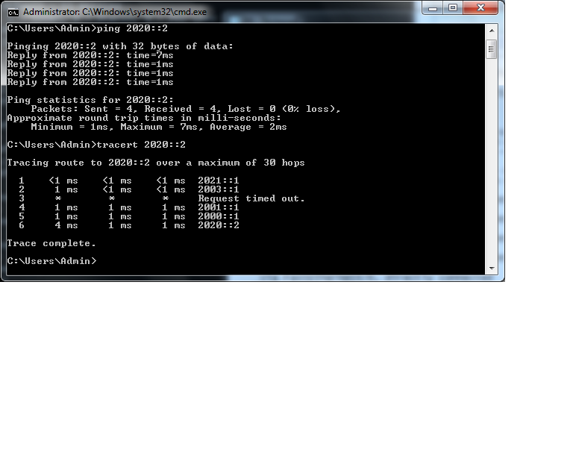

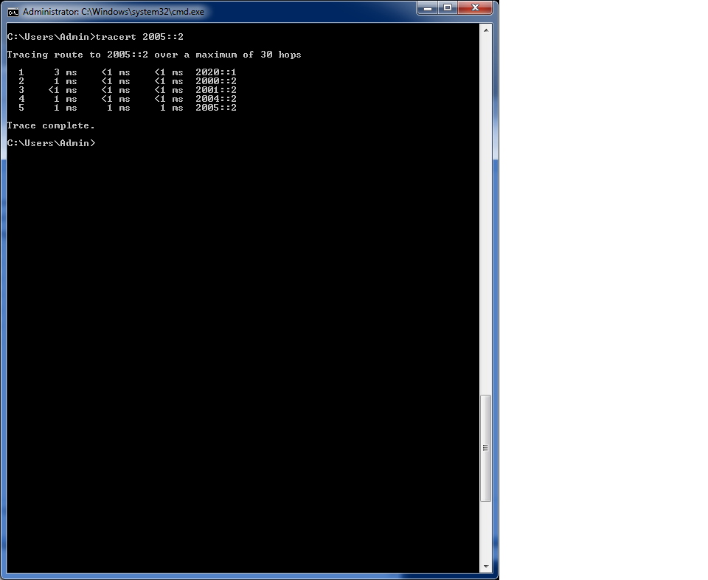



**PC1 ipconfig**  
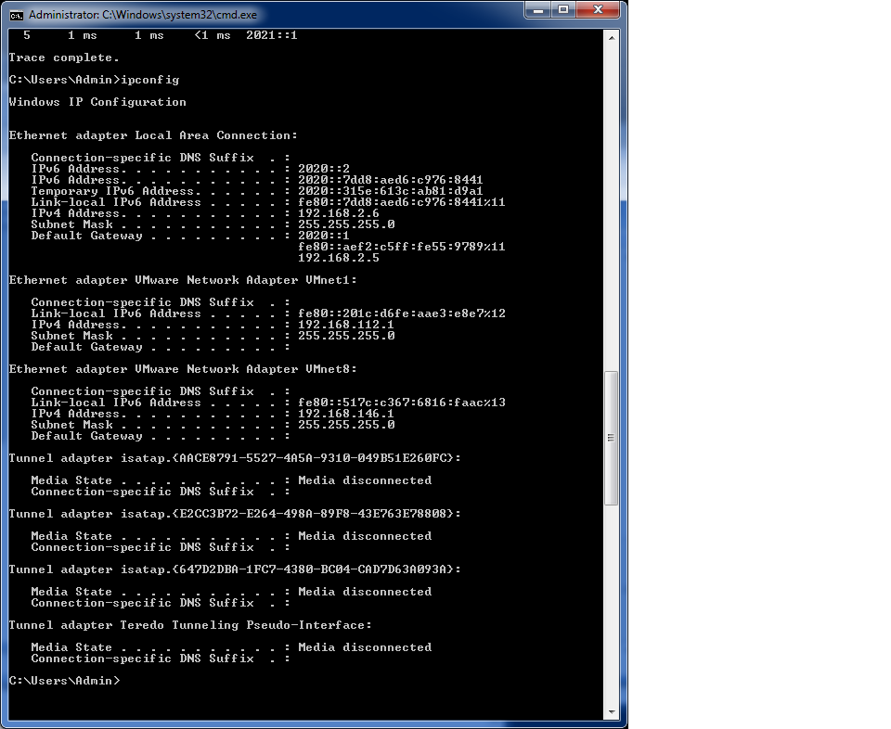

**PC2 ipconfig**

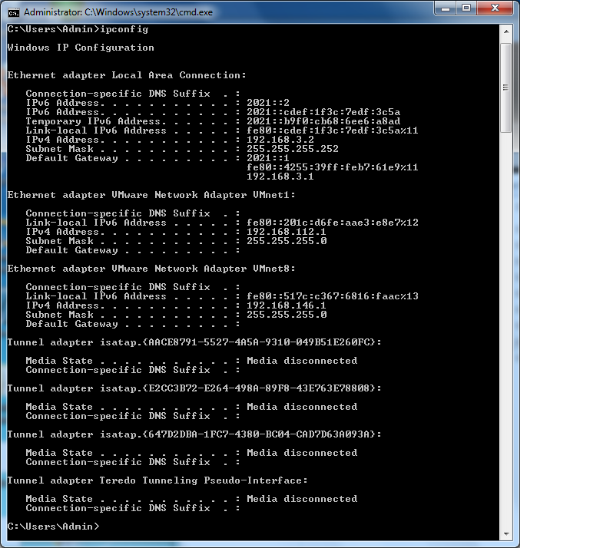

**IPv4 tracert and ping**

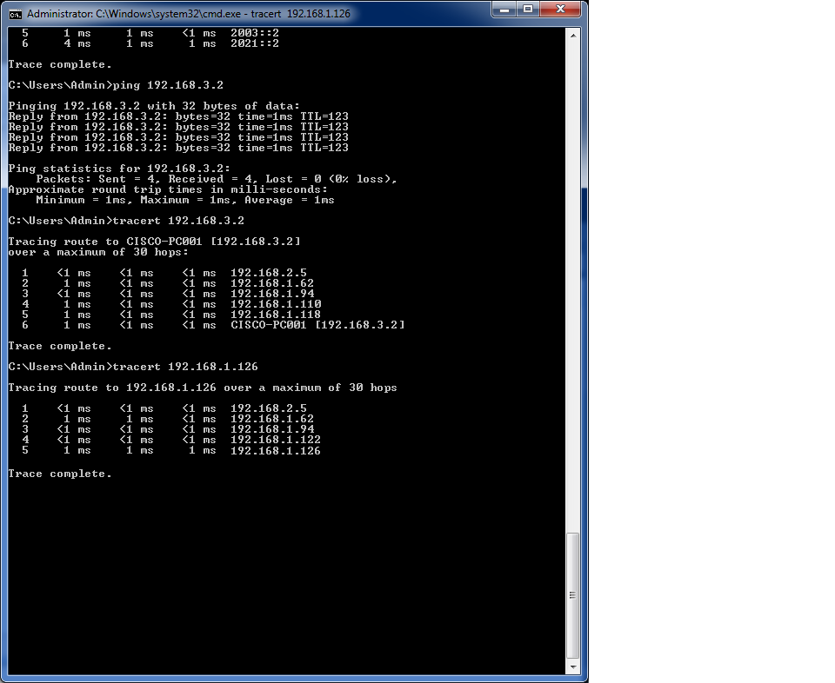

**Router/Switch show run and show ip route / show ipv6 route**

**Router 1**

Building configuration...

Current configuration : 1496 bytes

!

! Last configuration change at 14:55:17 UTC Fri Sep 20 2013

version 15.1

no service timestamps debug uptime

no service timestamps log uptime

no service password-encryption

!

hostname R1

!

!

no aaa new-model

memory-size iomem 10

!

ipv6 unicast-routing

ipv6 cef

ip source-route

ip cef

!

!

!

!

!

multilink bundle-name authenticated

!

!

crypto pki token default removal timeout 0

!

!

license udi pid CISCO2901/K9 sn FTX1704Y03B

!

interface GigabitEthernet0/0

ip address 192.168.1.1 255.255.255.192

duplex auto

speed auto

ipv6 address 2000::1/64

ipv6 ospf 1 area 0

!

interface GigabitEthernet0/1

ip address 192.168.2.5 255.255.255.252

duplex auto

speed auto

ipv6 address 2020::1/64

ipv6 ospf 1 area 0

!

router ospf 1

router-id 192.168.1.1

network 192.168.1.0 0.0.0.63 area 0

network 192.168.2.4 0.0.0.3 area 0

!

ip forward-protocol nd

!

no ip http server

no ip http secure-server

!

!

ipv6 router ospf 1

router-id 192.168.1.1

!

!

!

!

control-plane

!

!

!

line con 0

line aux 0

line 2

no activation-character

no exec

transport preferred none

transport input all

transport output pad telnet rlogin lapb-ta mop udptn v120 ssh

stopbits 1

line vty 0 4

login

transport input all

!

scheduler allocate 20000 1000

end

192.168.1.0/24 is variably subnetted, 7 subnets, 6 masks

C 192.168.1.0/26 is directly connected, GigabitEthernet0/0

L 192.168.1.1/32 is directly connected, GigabitEthernet0/0

O 192.168.1.64/27

[110/2] via 192.168.1.62, 01:06:26, GigabitEthernet0/0

O 192.168.1.96/28

[110/3] via 192.168.1.62, 01:06:26, GigabitEthernet0/0

O 192.168.1.112/29

[110/4] via 192.168.1.62, 01:05:48, GigabitEthernet0/0

O E2 192.168.1.120/30

[110/20] via 192.168.1.62, 01:06:26, GigabitEthernet0/0

O E2 192.168.1.124/30

[110/20] via 192.168.1.62, 00:36:28, GigabitEthernet0/0

192.168.2.0/24 is variably subnetted, 2 subnets, 2 masks

C 192.168.2.4/30 is directly connected, GigabitEthernet0/1

L 192.168.2.5/32 is directly connected, GigabitEthernet0/1

192.168.3.0/30 is subnetted, 1 subnets

O 192.168.3.0 [110/5] via 192.168.1.62, 01:05:48, GigabitEthernet0/0

IPv6 Routing Table - default - 10 entries

Codes: C - Connected, L - Local, S - Static, U - Per-user Static route

B - BGP, R - RIP, I1 - ISIS L1, I2 - ISIS L2

IA - ISIS interarea, IS - ISIS summary, D - EIGRP, EX - EIGRP external

ND - Neighbor Discovery, l - LISP

O - OSPF Intra, OI - OSPF Inter, OE1 - OSPF ext 1, OE2 - OSPF ext 2

ON1 - OSPF NSSA ext 1, ON2 - OSPF NSSA ext 2

C 2000::/64 [0/0]

via GigabitEthernet0/0, directly connected

L 2000::1/128 [0/0]

via GigabitEthernet0/0, receive

O 2001::/64 [110/2]

via FE80::217:E0FF:FE51:B2B0, GigabitEthernet0/0

O 2002::/64 [110/3]

via FE80::217:E0FF:FE51:B2B0, GigabitEthernet0/0

O 2003::/64 [110/4]

via FE80::217:E0FF:FE51:B2B0, GigabitEthernet0/0

OE2 2005::/64 [110/10]

via FE80::217:E0FF:FE51:B2B0, GigabitEthernet0/0

C 2020::/64 [0/0]

via GigabitEthernet0/1, directly connected

L 2020::1/128 [0/0]

via GigabitEthernet0/1, receive

O 2021::/64 [110/5]

via FE80::217:E0FF:FE51:B2B0, GigabitEthernet0/0

L FF00::/8 [0/0]

via Null0, receive

Router 2

Current configuration : 1619 bytes

!

version 12.4

service timestamps debug datetime msec

service timestamps log datetime msec

no service password-encryption

!

hostname R2

!

boot-start-marker

boot-end-marker

!

logging message-counter syslog

!

no aaa new-model

memory-size iomem 10

!

dot11 syslog

ip source-route

!

!

ip cef

!

!

ipv6 unicast-routing

ipv6 cef

!

interface FastEthernet0/0

ip address 192.168.1.62 255.255.255.192

duplex auto

speed auto

ipv6 address 2000::2/64

ipv6 ospf 1 area 0

!

interface FastEthernet0/1

ip address 192.168.1.65 255.255.255.224

duplex auto

speed auto

ipv6 address 2001::1/64

ipv6 ospf 1 area 0

!

router ospf 1

router-id 192.168.1.65

log-adjacency-changes

network 192.168.1.0 0.0.0.63 area 0

network 192.168.1.64 0.0.0.31 area 0

!

ip forward-protocol nd

no ip http server

no ip http secure-server

!

!

!

ipv6 router ospf 1

router-id 192.168.1.65

log-adjacency-changes

!

!

control-plane

!

!

line con 0

line aux 0

line vty 0 4

login

!

scheduler allocate 20000 1000

end

IPv6 Routing Table - Default - 11 entries

Codes: C - Connected, L - Local, S - Static, U - Per-user Static route

B - BGP, M - MIPv6, R - RIP, I1 - ISIS L1

I2 - ISIS L2, IA - ISIS interarea, IS - ISIS summary, D - EIGRP

EX - EIGRP external

O - OSPF Intra, OI - OSPF Inter, OE1 - OSPF ext 1, OE2 - OSPF ext 2

ON1 - OSPF NSSA ext 1, ON2 - OSPF NSSA ext 2

C 2000::/64 [0/0]

via FastEthernet0/0, directly connected

L 2000::2/128 [0/0]

via FastEthernet0/0, receive

C 2001::/64 [0/0]

via FastEthernet0/1, directly connected

L 2001::1/128 [0/0]

via FastEthernet0/1, receive

O 2002::/64 [110/2]

via FE80::2D0:2BFF:FE15:110A, FastEthernet0/1

O 2003::/64 [110/3]

via FE80::2D0:2BFF:FE15:110A, FastEthernet0/1

O 2004::/64 [110/2]

via FE80::2D0:2BFF:FE15:110A, FastEthernet0/1

OE2 2005::/64 [110/10]

via FE80::2D0:2BFF:FE15:110A, FastEthernet0/1

O 2020::/64 [110/2]

via FE80::AEF2:C5FF:FE55:9788, FastEthernet0/0

O 2021::/64 [110/4]

via FE80::2D0:2BFF:FE15:110A, FastEthernet0/1

L FF00::/8 [0/0]

via Null0, receive

Codes: C - connected, S - static, R - RIP, M - mobile, B - BGP

D - EIGRP, EX - EIGRP external, O - OSPF, IA - OSPF inter area

N1 - OSPF NSSA external type 1, N2 - OSPF NSSA external type 2

E1 - OSPF external type 1, E2 - OSPF external type 2

i - IS-IS, su - IS-IS summary, L1 - IS-IS level-1, L2 - IS-IS level-2

ia - IS-IS inter area, * - candidate default, U - per-user static route

o - ODR, P - periodic downloaded static route

Gateway of last resort is not set

192.168.1.0/24 is variably subnetted, 6 subnets, 5 masks

O 192.168.1.96/28 [110/2] via 192.168.1.94, 01:15:18, FastEthernet0/1

O E2 192.168.1.120/30 [110/20] via 192.168.1.94, 01:15:18, FastEthernet0/1

O E2 192.168.1.124/30 [110/20] via 192.168.1.94, 00:45:18, FastEthernet0/1

O 192.168.1.112/29 [110/3] via 192.168.1.94, 01:14:38, FastEthernet0/1

C 192.168.1.64/27 is directly connected, FastEthernet0/1

C 192.168.1.0/26 is directly connected, FastEthernet0/0

192.168.2.0/30 is subnetted, 1 subnets

O 192.168.2.4 [110/2] via 192.168.1.1, 01:15:09, FastEthernet0/0

192.168.3.0/30 is subnetted, 1 subnets

O 192.168.3.0 [110/4] via 192.168.1.94, 01:14:39, FastEthernet0/1

**Router 3**

Current configuration : 1454 bytes

!

version 12.4

no service timestamps debug uptime

no service timestamps log uptime

no service password-encryption

!

hostname R3

!

boot-start-marker

boot-end-marker

!

logging message-counter syslog

!

no aaa new-model

memory-size iomem 10

!

dot11 syslog

ip source-route

!

!

ip cef

!

!

no ip domain lookup

ipv6 unicast-routing

ipv6 cef

!

multilink bundle-name authenticated

!

!

!

!

!

!

!

!

interface FastEthernet0/0

ip address 192.168.1.110 255.255.255.240

duplex auto

speed auto

ipv6 address 2002::2/64

ipv6 ospf 1 area 0

!

interface FastEthernet0/1

ip address 192.168.1.113 255.255.255.248

duplex auto

speed auto

ipv6 address 2003::1/64

ipv6 ospf 1 area 0

!

router ospf 1

router-id 192.168.1.113

log-adjacency-changes

network 192.168.1.96 0.0.0.15 area 0

network 192.168.1.112 0.0.0.7 area 0

!

ip forward-protocol nd

no ip http server

no ip http secure-server

!

!

!

ipv6 router ospf 1

router-id 192.168.1.113

log-adjacency-changes

!

!

!

line con 0

line aux 0

line vty 0 4

login

!

end

Codes: C - connected, S - static, R - RIP, M - mobile, B - BGP

D - EIGRP, EX - EIGRP external, O - OSPF, IA - OSPF inter area

N1 - OSPF NSSA external type 1, N2 - OSPF NSSA external type 2

E1 - OSPF external type 1, E2 - OSPF external type 2

i - IS-IS, su - IS-IS summary, L1 - IS-IS level-1, L2 - IS-IS level-2

ia - IS-IS inter area, * - candidate default, U - per-user static route

o - ODR, P - periodic downloaded static route

Gateway of last resort is not set

192.168.1.0/24 is variably subnetted, 6 subnets, 5 masks

C 192.168.1.96/28 is directly connected, FastEthernet0/0

O E2 192.168.1.120/30 [110/20] via 192.168.1.97, 01:16:06, FastEthernet0/0

O E2 192.168.1.124/30 [110/20] via 192.168.1.97, 00:46:36, FastEthernet0/0

C 192.168.1.112/29 is directly connected, FastEthernet0/1

O 192.168.1.64/27 [110/2] via 192.168.1.97, 01:16:06, FastEthernet0/0

O 192.168.1.0/26 [110/3] via 192.168.1.97, 01:16:06, FastEthernet0/0

192.168.2.0/30 is subnetted, 1 subnets

O 192.168.2.4 [110/4] via 192.168.1.97, 01:16:07, FastEthernet0/0

192.168.3.0/30 is subnetted, 1 subnets

O 192.168.3.0 [110/2] via 192.168.1.118, 01:15:57, FastEthernet0/1

IPv6 Routing Table - Default - 11 entries

Codes: C - Connected, L - Local, S - Static, U - Per-user Static route

B - BGP, M - MIPv6, R - RIP, I1 - ISIS L1

I2 - ISIS L2, IA - ISIS interarea, IS - ISIS summary, D - EIGRP

EX - EIGRP external

O - OSPF Intra, OI - OSPF Inter, OE1 - OSPF ext 1, OE2 - OSPF ext 2

ON1 - OSPF NSSA ext 1, ON2 - OSPF NSSA ext 2

O 2000::/64 [110/3]

via FE80::2D0:2BFF:FE15:110A, FastEthernet0/0

O 2001::/64 [110/2]

via FE80::2D0:2BFF:FE15:110A, FastEthernet0/0

C 2002::/64 [0/0]

via FastEthernet0/0, directly connected

L 2002::2/128 [0/0]

via FastEthernet0/0, receive

C 2003::/64 [0/0]

via FastEthernet0/1, directly connected

L 2003::1/128 [0/0]

via FastEthernet0/1, receive

O 2004::/64 [110/2]

via FE80::2D0:2BFF:FE15:110A, FastEthernet0/0

OE2 2005::/64 [110/10]

via FE80::2D0:2BFF:FE15:110A, FastEthernet0/0

O 2020::/64 [110/4]

via FE80::2D0:2BFF:FE15:110A, FastEthernet0/0

O 2021::/64 [110/2]

via FE80::4255:39FF:FEB7:61E8, FastEthernet0/1

L FF00::/8 [0/0]

via Null0, receive

**Router 4**

Current configuration : 1290 bytes

!

!

version 15.0

no service timestamps debug uptime

no service timestamps log uptime

no service password-encryption

!

hostname R4

!

boot-start-marker

boot-end-marker

!

!

no aaa new-model

!

!

!

memory-size iomem 25

!

ipv6 unicast-routing

ipv6 cef

ip source-route

ip cef

!

!

!

!

!

!

!

interface GigabitEthernet0/0

ip address 192.168.1.118 255.255.255.248

duplex auto

speed auto

ipv6 address 2003::2/64

ipv6 ospf 1 area 0

!

!

interface GigabitEthernet0/1

ip address 192.168.3.1 255.255.255.252

duplex auto

speed auto

ipv6 address 2021::1/64

ipv6 ospf 1 area 0

!

!

router ospf 1

router-id 192.168.1.112

log-adjacency-changes

network 192.168.1.112 0.0.0.7 area 0

network 192.168.3.0 0.0.0.3 area 0

!

ip forward-protocol nd

!

no ip http server

no ip http secure-server

!

!

ipv6 router ospf 1

router-id 192.168.1.112

log-adjacency-changes

!

!

line con 0

line aux 0

line vty 0 4

login

!

scheduler allocate 20000 1000

end

Codes: L - local, C - connected, S - static, R - RIP, M - mobile, B - BGP

D - EIGRP, EX - EIGRP external, O - OSPF, IA - OSPF inter area

N1 - OSPF NSSA external type 1, N2 - OSPF NSSA external type 2

E1 - OSPF external type 1, E2 - OSPF external type 2

i - IS-IS, su - IS-IS summary, L1 - IS-IS level-1, L2 - IS-IS level-2

ia - IS-IS inter area, * - candidate default, U - per-user static route

o - ODR, P - periodic downloaded static route, + - replicated route

Gateway of last resort is not set

192.168.1.0/24 is variably subnetted, 7 subnets, 6 masks

O 192.168.1.0/26

[110/4] via 192.168.1.113, 01:17:33, GigabitEthernet0/0

O 192.168.1.64/27

[110/3] via 192.168.1.113, 01:17:33, GigabitEthernet0/0

O 192.168.1.96/28

[110/2] via 192.168.1.113, 01:17:33, GigabitEthernet0/0

C 192.168.1.112/29 is directly connected, GigabitEthernet0/0

L 192.168.1.118/32 is directly connected, GigabitEthernet0/0

O E2 192.168.1.120/30

[110/20] via 192.168.1.113, 01:17:33, GigabitEthernet0/0

O E2 192.168.1.124/30

[110/20] via 192.168.1.113, 00:48:12, GigabitEthernet0/0

192.168.2.0/30 is subnetted, 1 subnets

O 192.168.2.4 [110/5] via 192.168.1.113, 01:17:34, GigabitEthernet0/0

192.168.3.0/24 is variably subnetted, 2 subnets, 2 masks

C 192.168.3.0/30 is directly connected, GigabitEthernet0/1

L 192.168.3.1/32 is directly connected, GigabitEthernet0/1

IPv6 Routing Table - default - 11 entries

Codes: C - Connected, L - Local, S - Static, U - Per-user Static route

B - BGP, HA - Home Agent, MR - Mobile Router, R - RIP

I1 - ISIS L1, I2 - ISIS L2, IA - ISIS interarea, IS - ISIS summary

D - EIGRP, EX - EIGRP external, ND - Neighbor Discovery

O - OSPF Intra, OI - OSPF Inter, OE1 - OSPF ext 1, OE2 - OSPF ext 2

ON1 - OSPF NSSA ext 1, ON2 - OSPF NSSA ext 2

O 2000::/64 [110/4]

via FE80::218:19FF:FECD:92C9, GigabitEthernet0/0

O 2001::/64 [110/3]

via FE80::218:19FF:FECD:92C9, GigabitEthernet0/0

O 2002::/64 [110/2]

via FE80::218:19FF:FECD:92C9, GigabitEthernet0/0

C 2003::/64 [0/0]

via GigabitEthernet0/0, directly connected

L 2003::2/128 [0/0]

via GigabitEthernet0/0, receive

O 2004::/64 [110/3]

via FE80::218:19FF:FECD:92C9, GigabitEthernet0/0

OE2 2005::/64 [110/10]

via FE80::218:19FF:FECD:92C9, GigabitEthernet0/0

O 2020::/64 [110/5]

via FE80::218:19FF:FECD:92C9, GigabitEthernet0/0

C 2021::/64 [0/0]

via GigabitEthernet0/1, directly connected

L 2021::1/128 [0/0]

via GigabitEthernet0/1, receive

L FF00::/8 [0/0]

via Null0, receive

**Router 5**

Current configuration : 1464 bytes

!

!

version 15.0

service timestamps debug datetime msec

service timestamps log datetime msec

no service password-encryption

!

hostname R5

!

boot-start-marker

boot-end-marker

!

!

no aaa new-model

!

!

!

memory-size iomem 10

!

ipv6 unicast-routing

ipv6 cef

ip source-route

ip cef

!

!

interface Tunnel0

no ip address

ipv6 address 2010::1/64

tunnel source GigabitEthernet0/1

tunnel destination 192.168.1.126

!

!

interface GigabitEthernet0/0

ip address 192.168.1.122 255.255.255.252

duplex auto

speed auto

ipv6 address 2004::2/64

ipv6 rip cisco enable

!

!

interface GigabitEthernet0/1

ip address 192.168.1.125 255.255.255.252

duplex auto

speed auto

ipv6 address 2005::1/64

ipv6 rip cisco enable

!

!

!

router rip

version 2

network 192.168.1.0

no auto-summary

!

ip forward-protocol nd

!

no ip http server

no ip http secure-server

!

!

ipv6 router rip cisco

!

!

line con 0

line aux 0

line vty 0 4

login

!

scheduler allocate 20000 1000

end

Codes: L - local, C - connected, S - static, R - RIP, M - mobile, B - BGP

D - EIGRP, EX - EIGRP external, O - OSPF, IA - OSPF inter area

N1 - OSPF NSSA external type 1, N2 - OSPF NSSA external type 2

E1 - OSPF external type 1, E2 - OSPF external type 2

i - IS-IS, su - IS-IS summary, L1 - IS-IS level-1, L2 - IS-IS level-2

ia - IS-IS inter area, * - candidate default, U - per-user static route

o - ODR, P - periodic downloaded static route, + - replicated route

Gateway of last resort is not set

192.168.1.0/24 is variably subnetted, 8 subnets, 6 masks

R 192.168.1.0/26

[120/10] via 192.168.1.121, 00:00:22, GigabitEthernet0/0

R 192.168.1.64/27

[120/1] via 192.168.1.121, 00:00:22, GigabitEthernet0/0

R 192.168.1.96/28

[120/1] via 192.168.1.121, 00:00:22, GigabitEthernet0/0

R 192.168.1.112/29

[120/10] via 192.168.1.121, 00:00:22, GigabitEthernet0/0

C 192.168.1.120/30 is directly connected, GigabitEthernet0/0

L 192.168.1.122/32 is directly connected, GigabitEthernet0/0

C 192.168.1.124/30 is directly connected, GigabitEthernet0/1

L 192.168.1.125/32 is directly connected, GigabitEthernet0/1

192.168.2.0/30 is subnetted, 1 subnets

R 192.168.2.4 [120/10] via 192.168.1.121, 00:00:23, GigabitEthernet0/0

192.168.3.0/30 is subnetted, 1 subnets

R 192.168.3.0 [120/10] via 192.168.1.121, 00:00:23, GigabitEthernet0/0

IPv6 Routing Table - default - 11 entries

Codes: C - Connected, L - Local, S - Static, U - Per-user Static route

B - BGP, HA - Home Agent, MR - Mobile Router, R - RIP

I1 - ISIS L1, I2 - ISIS L2, IA - ISIS interarea, IS - ISIS summary

D - EIGRP, EX - EIGRP external, ND - Neighbor Discovery

O - OSPF Intra, OI - OSPF Inter, OE1 - OSPF ext 1, OE2 - OSPF ext 2

ON1 - OSPF NSSA ext 1, ON2 - OSPF NSSA ext 2

R 2000::/64 [120/11]

via FE80::2D0:2BFF:FE15:110A, GigabitEthernet0/0

R 2001::/64 [120/2]

via FE80::2D0:2BFF:FE15:110A, GigabitEthernet0/0

R 2002::/64 [120/2]

via FE80::2D0:2BFF:FE15:110A, GigabitEthernet0/0

R 2003::/64 [120/11]

via FE80::2D0:2BFF:FE15:110A, GigabitEthernet0/0

C 2004::/64 [0/0]

via GigabitEthernet0/0, directly connected

L 2004::2/128 [0/0]

via GigabitEthernet0/0, receive

C 2005::/64 [0/0]

via GigabitEthernet0/1, directly connected

L 2005::1/128 [0/0]

via GigabitEthernet0/1, receive

R 2020::/64 [120/11]

via FE80::2D0:2BFF:FE15:110A, GigabitEthernet0/0

R 2021::/64 [120/11]

via FE80::2D0:2BFF:FE15:110A, GigabitEthernet0/0

L FF00::/8 [0/0]

via Null0, receive

**Router 6**

Current configuration : 1957 bytes

!

version 12.4

no service timestamps debug uptime

no service timestamps log uptime

no service password-encryption

!

hostname R6

!

boot-start-marker

boot-end-marker

!

logging message-counter syslog

!

no aaa new-model

memory-size iomem 10

no network-clock-participate slot 1

!

dot11 syslog

ip source-route

!

!

ip cef

!

!

ipv6 unicast-routing

ipv6 cef

!

archive

log config

hidekeys

!

!

interface FastEthernet0/0

ip address 192.168.1.126 255.255.255.252

duplex auto

speed auto

ipv6 address 2005::2/64

ipv6 rip cisco enable

!

router ospf 1

router-id 192.168.1.126

log-adjacency-changes

!

router rip

version 2

network 192.168.1.0

no auto-summary

!

ip forward-protocol nd

no ip http server

no ip http secure-server

!

!

!

ipv6 router ospf 1

router-id 192.168.1.126

log-adjacency-changes

!

ipv6 router rip cisco

!

!

!

line con 0

line aux 0

line vty 0 4

login

!

scheduler allocate 20000 1000

end

Codes: C - connected, S - static, R - RIP, M - mobile, B - BGP

D - EIGRP, EX - EIGRP external, O - OSPF, IA - OSPF inter area

N1 - OSPF NSSA external type 1, N2 - OSPF NSSA external type 2

E1 - OSPF external type 1, E2 - OSPF external type 2

i - IS-IS, su - IS-IS summary, L1 - IS-IS level-1, L2 - IS-IS level-2

ia - IS-IS inter area, * - candidate default, U - per-user static route

o - ODR, P - periodic downloaded static route

Gateway of last resort is not set

192.168.1.0/24 is variably subnetted, 6 subnets, 5 masks

R 192.168.1.96/28 [120/2] via 192.168.1.125, 00:00:18, FastEthernet0/0

R 192.168.1.120/30 [120/1] via 192.168.1.125, 00:00:18, FastEthernet0/0

C 192.168.1.124/30 is directly connected, FastEthernet0/0

R 192.168.1.112/29 [120/11] via 192.168.1.125, 00:00:18, FastEthernet0/0

R 192.168.1.64/27 [120/2] via 192.168.1.125, 00:00:18, FastEthernet0/0

R 192.168.1.0/26 [120/11] via 192.168.1.125, 00:00:18, FastEthernet0/0

192.168.2.0/30 is subnetted, 1 subnets

R 192.168.2.4 [120/11] via 192.168.1.125, 00:00:20, FastEthernet0/0

192.168.3.0/30 is subnetted, 1 subnets

R 192.168.3.0 [120/11] via 192.168.1.125, 00:00:20, FastEthernet0/0

IPv6 Routing Table - Default - 9 entries

Codes: C - Connected, L - Local, S - Static, U - Per-user Static route

B - BGP, M - MIPv6, R - RIP, I1 - ISIS L1

I2 - ISIS L2, IA - ISIS interarea, IS - ISIS summary, D - EIGRP

EX - EIGRP external

O - OSPF Intra, OI - OSPF Inter, OE1 - OSPF ext 1, OE2 - OSPF ext 2

ON1 - OSPF NSSA ext 1, ON2 - OSPF NSSA ext 2

R 2000::/64 [120/12]

via FE80::EAB7:48FF:FE6E:89, FastEthernet0/0

R 2002::/64 [120/3]

via FE80::EAB7:48FF:FE6E:89, FastEthernet0/0

R 2003::/64 [120/12]

via FE80::EAB7:48FF:FE6E:89, FastEthernet0/0

R 2004::/64 [120/2]

via FE80::EAB7:48FF:FE6E:89, FastEthernet0/0

C 2005::/64 [0/0]

via FastEthernet0/0, directly connected

L 2005::2/128 [0/0]

via FastEthernet0/0, receive

R 2020::/64 [120/12]

via FE80::EAB7:48FF:FE6E:89, FastEthernet0/0

R 2021::/64 [120/12]

via FE80::EAB7:48FF:FE6E:89, FastEthernet0/0

L FF00::/8 [0/0]

via Null0, receive

**Switch 1**

Building configuration...

Current configuration : 16931 bytes

!

upgrade fpd auto

version 12.2

service timestamps debug uptime

service timestamps log uptime

no service password-encryption

service counters max age 5

!

hostname S1

!

boot system slot0:s222-adventerprisek9_wan-mz.122-18.SXF17b.bin

!

no aaa new-model

ip subnet-zero

!

!

!

ipv6 unicast-routing

!

!

!

!

!

vlan internal allocation policy ascending

!

!

!

!

interface FastEthernet4/1

ip address 192.168.1.94 255.255.255.224

ipv6 address 2001::2/64

ipv6 ospf 1 area 0

no shutdown

!

interface FastEthernet4/2

ip address 192.168.1.97 255.255.255.240

ipv6 address 2002::1/64

ipv6 ospf 1 area 0

no shutdown

!

interface FastEthernet4/3

ip address 192.168.1.121 255.255.255.252

ipv6 address 2004::1/64

ipv6 rip cisco enable

no shutdown

!

router ospf 1

router-id 192.168.1.121

log-adjacency-changes

redistribute rip subnets

network 192.168.1.64 0.0.0.31 area 0

network 192.168.1.96 0.0.0.15 area 0

!

router rip

version 2

redistribute ospf 1 metric 10

network 192.168.1.0

no auto-summary

!

ip classless

!

no ip http server

!

ipv6 router ospf 1

router-id 192.168.1.121

log-adjacency-changes

redistribute rip cisco metric 10

!

ipv6 router rip cisco

redistribute ospf 1 metric 10

!

!

!

line con 0

line vty 0 4

login

!

no cns aaa enable

end

IPv6 Routing Table - 13 entries

Codes: C - Connected, L - Local, S - Static, R - RIP, B - BGP

U - Per-user Static route

I1 - ISIS L1, I2 - ISIS L2, IA - ISIS interarea, IS - ISIS summary

O - OSPF intra, OI - OSPF inter, OE1 - OSPF ext 1, OE2 - OSPF ext 2

ON1 - OSPF NSSA ext 1, ON2 - OSPF NSSA ext 2

O 2000::/64 [110/2]

via FE80::217:E0FF:FE51:B2B1, FastEthernet4/1

C 2001::/64 [0/0]

via ::, FastEthernet4/1

L 2001::2/128 [0/0]

via ::, FastEthernet4/1

C 2002::/64 [0/0]

via ::, FastEthernet4/2

L 2002::1/128 [0/0]

via ::, FastEthernet4/2

O 2003::/64 [110/2]

via FE80::218:19FF:FECD:92C8, FastEthernet4/2

C 2004::/64 [0/0]

via ::, FastEthernet4/3

L 2004::1/128 [0/0]

via ::, FastEthernet4/3

R 2005::/64 [120/2]

via FE80::EAB7:48FF:FE6E:88, FastEthernet4/3

O 2020::/64 [110/3]

via FE80::217:E0FF:FE51:B2B1, FastEthernet4/1

O 2021::/64 [110/3]

via FE80::218:19FF:FECD:92C8, FastEthernet4/2

L FE80::/10 [0/0]

via ::, Null0

L FF00::/8 [0/0]

via ::, Null0

Codes: C - connected, S - static, R - RIP, M - mobile, B - BGP

D - EIGRP, EX - EIGRP external, O - OSPF, IA - OSPF inter area

N1 - OSPF NSSA external type 1, N2 - OSPF NSSA external type 2

E1 - OSPF external type 1, E2 - OSPF external type 2, E - EGP

i - IS-IS, su - IS-IS summary, L1 - IS-IS level-1, L2 - IS-IS level-2

ia - IS-IS inter area, * - candidate default, U - per-user static route

o - ODR, P - periodic downloaded static route

Gateway of last resort is not set

192.168.1.0/24 is variably subnetted, 6 subnets, 5 masks

C 192.168.1.96/28 is directly connected, FastEthernet4/2

C 192.168.1.120/30 is directly connected, FastEthernet4/3

R 192.168.1.124/30 [120/1] via 192.168.1.122, 00:00:05, FastEthernet4/3

O 192.168.1.112/29 [110/2] via 192.168.1.110, 00:58:18, FastEthernet4/2

C 192.168.1.64/27 is directly connected, FastEthernet4/1

O 192.168.1.0/26 [110/2] via 192.168.1.65, 00:58:18, FastEthernet4/1

192.168.2.0/30 is subnetted, 1 subnets

O 192.168.2.4 [110/3] via 192.168.1.65, 00:58:19, FastEthernet4/1

192.168.3.0/30 is subnetted, 1 subnets

O 192.168.3.0 [110/3] via 192.168.1.110, 00:58:19, FastEthernet4/2

**Problems**

Problems with redistribution were prevalent in this lab. As I mentioned earlier, network statements with “O E2” were not showing up on any routers and I could not ping nor trace route between any of the top Routers with the bottom routers. The process of researching the appropriate protocols consumed more time than I expected. I eventually reached the point where all routes were present except the redistribution and thus had to struggle to fix the redistribution problems.

**Conclusion**

Although the lab consumed more time than I had expected due to the difficulty with redistributing different routing protocols, the overall result of this lab was satisfactory. I enabled the concurrent run on IPv4 and IPv6 on every network present being able to ping and trace route from one end to the other. I’ve learned how to manage OSPF, OSPF v3, RIP, and RIPng simultaneously, with IPv4 and IPv6 addresses, an experience that I never had in CCNA.